29.26: a) Using Equation (29.6): 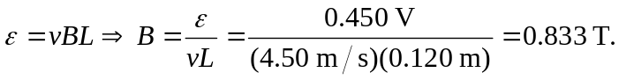
b) Point a is at a higher potential than point b, because there are more positive charges there.

